**GANPAT UNIVERSITY**

**U.V.PATEL COLLEGE OF ENGINEERING & TECHNOLOGY**

**Department of Computer Science and Engineering**

**B.Tech 1ST Semester   Subject – ESFP**

**First Name: Dular Patel      Enrollment Number: 14012121007  Stream: Big Data & Analytics**

**Assignment -2                                                                                  Date: 27/08/2014**

Goal: Assignment

Requirements – Computer

1. Write a program to print ASCII values of all backslash characters and white space on screen.

Answer:

#include<stdio.h>

#include<conio.h>

#include<math.h>

void main()

{

clrscr();

char a,b,d,e,f,g,h,i,j,k,l,m;

int c;

a='\a';

b='\b';

d='\f';

e='\n';

f='\r';

g='\t';

h='\v';

i='\'';

j='\"';

k='\?';

l='\\';

m='\o';

c=a;

printf("\n ASCII value of\'\\a=%d",c);

c=b;

printf("\n ASCII value of \'\\b=%d",c);

c=d;

printf("\n ASCII value of \'\\f=%d",c);

c=e;

printf("\n ASCII value of \'\\n=%d",c);

c=f;

printf("\n ASCII value of \'\\r=%d",c);

c=g;

printf("\n ASCII value of \'\\t=%d",c);

c=h;

printf("\n ASCII value of \'\\v=%d",c);

c=i;

printf("\n ASCII value of \'\\\'\'=%d",c);

c=j;

printf("\n ASCII value of \'\\\"\'=%d",c);

c=k;

printf("\n ASCII value of \'\\?\'=%d",c);

c=l;

printf("\n ASCII value of \'\\\\\'=%d",c);

c=m;

printf("\n ASCII value of \'\\O\'=%d",c);

getch();

}

Output:

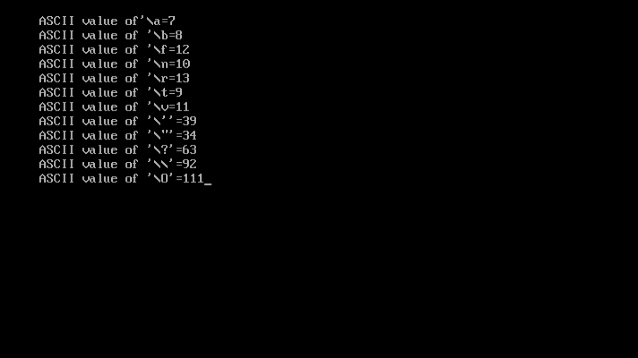

2. Explain different data types available in C.

Answer:

1. Integer Data Types: (int)

It ranges from -32,768 to 32,767. It is used to store integer numbers. They are further categorized as short (%d or %i) and long integers (%ld). Short integer occupies 2 bytes and long integer occupies 4 bytes in memory. They care also differentiated in signed (%d) and unsigned (%u) integers. Signed & unsigned both occupies 2 bytes in memory.

1. Character Data Types: (char)

They are used to store characters. It ranges from -128 to 127. They are further categorized as signed & unsigned character. Signed (%c) & unsigned (%c) occupies 1 byte & 2 byte in memory. Unsigned ranges from 0 to 255.

1. Floating Point: (float)

They are used to store floating point numbers. Float (%f) occupies 4 bytes size in memory. It ranges from3.4E-38 to +3.4E+38.

1. Double Data Type: (double)

They are used to store big floating point numbers. Double (%lf) occupies 8 bytes in memory. It ranges from 1.7E-308 to +1.7E+308.

1. Void Data Type: (void)

Void means valueless. They do not occupy any space in memory.

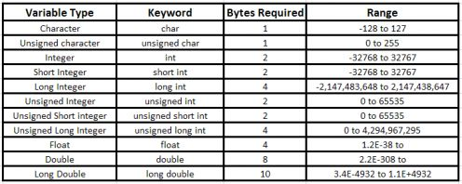

3. Explain about C Tokens in brief.

Answers:

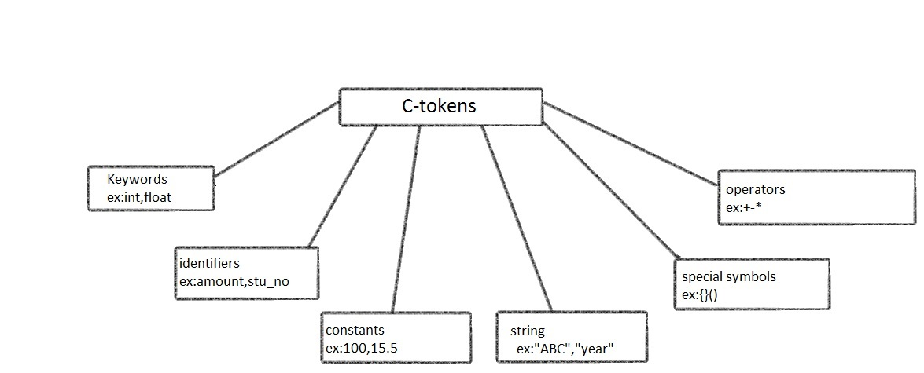

1. Keywords:

Keywords are reserved by the compiler. There are 32 keywords in ANSCI Standard.

1. Variables:

These are user defined. Any number of variables can be defined.

1. Constants:

Constants are assigned to variables.

1. Operators:

Operators are of different types and are used in expressions.

1. Special Characters:

These characters are used in different declarations in C.

1. Strings:

A sequence of characters.

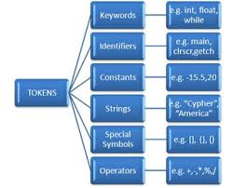

4. Explain about backslash characters in C.

Answers:

1. Properties:

1. Although it consists of two characters, it represents single character.

2. Each escape sequence has unique ASCII value.

3. Each and Every combination starts with back slash ().

4. They are non-printable characters.

5. It can also be expressed in terms of octal digits or hexadecimal sequence.

6. Escape sequence in character constants and string literals are replaced by their

equivalent and then adjacent string literals are concatenated

7. Escape Sequences are preprocessed by Preprocessor.

1. Examples:
2. Tab : ‘\t’ Character

* It is horizontal tab.
* Takes Control 8 spaces ahead in Borland CC++ 3.0 Compiler.

1. New Line Character: ‘\n’ Character

* It is new line character.
* It takes control to new line.

1. Back slash: ‘\b’ Character

* It is backslash character.
* Takes control one position back.

1. Carrier Return: ‘\a’ Character

* It is carrier return character.
* Takes control to first position in the line.

1. Audible Return: ‘\a’ Character

* It is audible return character.
* Beeps sound.